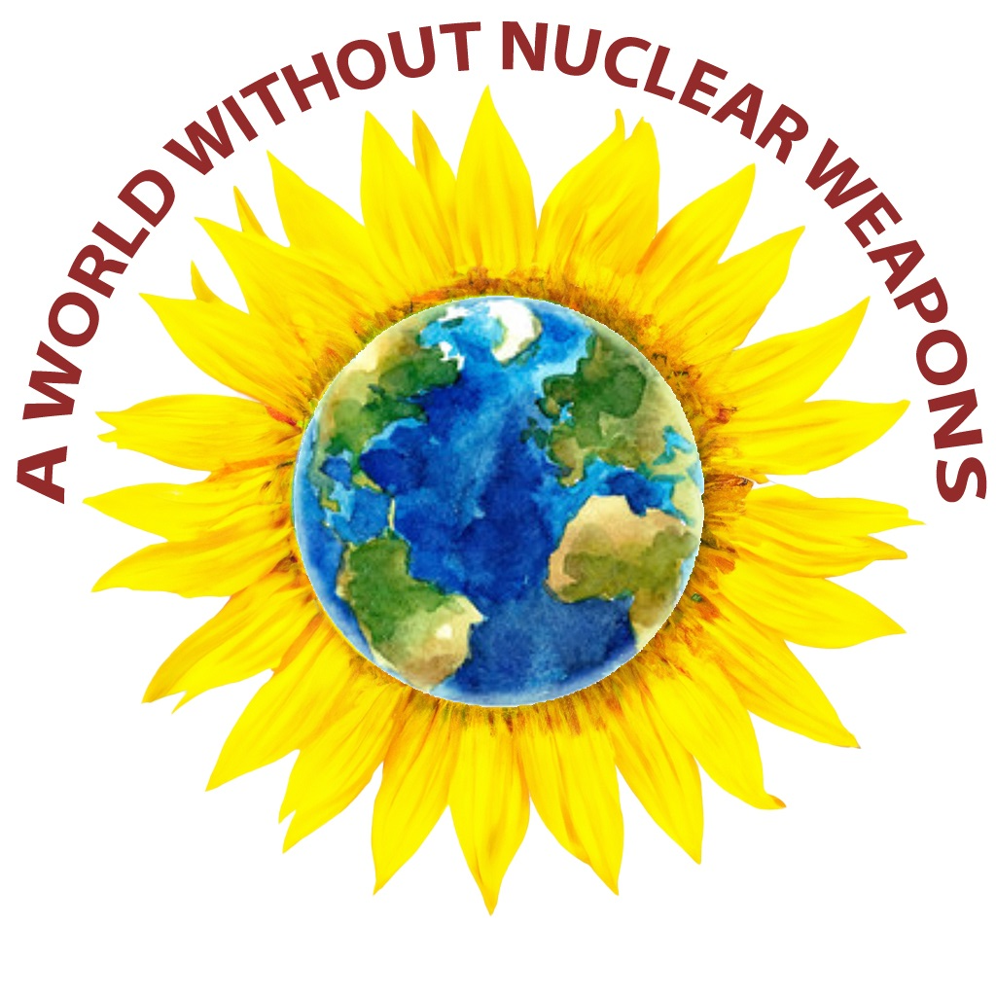
Sunday, July 19,2026 Doors Open at 2pm


At St. Michael’s High School - 100 Siringo Road, Santa Fe, NM 87505
All Are Welcome * Free * Reservations Highly Recommended
For reservations
Or Scan the QR code.

From Reflection to Action
An Interfaith Remembrance of the Trinity Test Event is organized by: The Archdiocese of Santa Fe,
Back From the Brink - New Mexico, Interfaith Power & Light, NM-EP, Nuclear Watch New Mexico, Soka Gakkai International-USA & Tularosa Basin Downwinders Consortium
At Saint Michael’s High School, 100 Siringo Road, Santa Fe, NM 87505

At St JOHN XXIII CATHOLIC COMMUNITY - 4831 TRAMWAY RIDGE DR NE, ALBUQUERQUE

